Software Requirement Engineering
BuyRight Web Application

Group Members:
- Muhammad Fasih Farhaj (BSE233116)
- Ibtesam Ul Haque (BSE233102)
- Azka Maryam (BSE233077)

Submitted To: Ma’am Qudsia Yousaf
Dated: 22-06-2025
Section-04

Table of Contents
1. Introduction 2
1.1 Purpose 2
1.2 References 2
2. Overall Description 2
2.1 User Classes and Characteristics 2
2.2 Operating Environment 3
2.3 Design and Implementation Constraints 4
2.4 Assumptions and Dependencies 5
3. External Interface Requirements 5
3.1 User Interfaces 5
3.2 Hardware Interfaces 5
3.3 Software Interfaces 5
3.4 Communication Interfaces 6
4. System Use Cases 6
4.1 Register User (UC1) 6
4.2 Login User (UC2) 7
4.3 Scan Products (UC3) 8
4.4 Display Alternative Product Suggestions (UC4) 9
4.5 Search for Non-boycotted Restaurants (UC5) 10
4.6 Switch Interface Language (UC6) 11
4.7 Share Scanned Product Information (UC7) 12
5. Other Non-functional Requirements 13
5.1 Performance Requirements 13
5.2 Safety Requirements 13
5.3 Security Requirements 13
5.4 Software Quality Attributes 13
6. Other Requirements 13
7. System Requirements 14
Appendix A: Analysis Models 15
Data Flow Diagram: 15
Domain Model Diagram: 15
System Sequence Diagrams: 16
Test Cases 20
Appendix B: 27

1. Introduction

1.1 Purpose
This Software Requirements Specification (SRS) document defines the requirements for BuyRight v1.0, a web-based application designed to help Pakistani consumers make ethical shopping decisions. The software enables users to identify products and restaurants affiliated with Israel and suggests safe, local alternatives. This document covers the entire system functionality intended for the initial public release, including user registration, product scanning, alternative recommendations, restaurant search, language switching, and sharing capabilities.

1.2 References
None

2. Overall Description

2.1 User Classes and Characteristics
User Class | Description | Importance
General Users | Everyday consumers in Pakistan who will use the app occasionally to scan products, find alternatives, and search ethical restaurants. These users are expected to have basic smartphone and web literacy. | High
Administrators | Backend managers responsible for updating boycott data, product records, alternative suggestions, and restaurant listings. They require higher privilege access and moderate technical knowledge. | High
Power Users | Frequent users (e.g., activists or informed consumers) who will use the app regularly, explore all features deeply, and may contribute boycott suggestions or feedback. | Medium
Guest Users (Optional) | Users accessing the app without logging in. They may be able to scan or search but not access personalized features. | Low (if implemented)

2.2 Operating Environment
BuyRight is a web-based application designed for cross-platform compatibility. It is optimized to run on the following environments:
- Browsers Supported:
  - Google Chrome (v100 and above)
  - Mozilla Firefox (v100 and above)
  - Microsoft Edge (v100 and above)
  - Safari (v14 and above)
- Devices Supported:
  - Desktop/Laptop (Windows 10+, macOS 11+)
  - Mobile Devices (Android 9+, iOS 13+ via modern browsers)
- Other Software Components:
  - HTML
  - Tailwind CSS
  - JavaScript
  - Noto Sans & Noto Serif Urdu fonts
  - MySQL (remote or local)
  - Python (Flask)
  - Barcode scanning libraries

2.3 Design and Implementation Constraints
The following constraints apply to the development and deployment of the BuyRight web application and may limit developer options:
- Technology Stack Constraint:
The application must be developed using HTML, Tailwind CSS, Python (Flask), and MySQL as per team decision. Alternative frameworks (e.g., Django, React) or databases (e.g., PostgreSQL, MongoDB) are not permitted in this version.
- Language Support:
The app must support English and Urdu. This introduces a constraint in UI layout design, RTL (right-to-left) compatibility for Urdu, and requires use of the Noto Serif Urdu font for proper rendering.
- Security Considerations:
As the system handles user credentials and potentially sensitive boycott data, it must implement secure authentication methods, password hashing, input validation, and protection against common web vulnerabilities (e.g., XSS, SQL injection). This adds complexity and limits use of simpler coding shortcuts.
- Design Consistency:
UI development must follow the minimalist color palette and Tailwind CSS design system approved for the project. Custom CSS frameworks or inline styles are discouraged to maintain consistency and responsiveness.
- No Use of Paid APIs or Commercial Services:
The application must rely only on free and open-source libraries. This restricts access to certain premium barcode databases or commercial boycott product APIs, requiring manual or community-curated data.

2.4 Assumptions and Dependencies
Assumptions
- Users will have reliable internet access for all web app functionalities including scanning and search.
- Barcode scanning relies on browser permission for camera access and WebRTC support.
- Users will access the app using updated browsers on supported devices.
- Urdu language support depends on the availability of correct translations and rendering using the Noto Serif Urdu font.
Dependencies
- The application depends on:
  - Flask framework to serve dynamic pages and handle backend logic.
  - Tailwind CSS for all frontend styling.
  - MySQL for managing user, product, boycott, and restaurant data.
  - WebRTC or similar JavaScript libraries

3. External Interface Requirements

3.1 User Interfaces
User Interface Standards for BuyRight
General Standards
- All buttons will have a black border.
- All fonts will be Arial, size 14px for body text and 18px for headings.
Screen Layout Components
- Menu Here: Top navigation bar with options (Home, Scan, Search Restaurants, Logout).
- Main Area: Centered content specific to the current task (e.g., forms, scan interface, search results).
- Status Bar: Bottom section for notifications, login status, or help icon.
Screen Layouts
- Default Welcome Screen
  - Menu Here: Top navigation bar.
  - Main Area: Welcome message, action buttons (Login, Register, Scan Product).
  - Status Bar: Login status.
- Login/Register Screens
  - Menu Here: Top navigation bar.
  - Main Area: Form with fields and action buttons.
  - Status Bar: Error or success messages.
- Scan Screen
  - Menu Here: Top navigation bar.
  - Main Area: Camera placeholder and scan button.
  - Status Bar: Scan status.
- Search Restaurants Screen
  - Menu Here: Top navigation bar.
  - Main Area: Search bar and restaurant grid.
  - Status Bar: Search status.
- Scan Result Screen
  - Menu Here: Top navigation bar.
  - Main Area: Product details and alternatives.
  - Status Bar: Boycott status.
Constraints and Standards
- Layout Constraints: Min width 320px, max width 1200px, 20px padding around main area.
- Standard Buttons/Functions: Logout (top-right), Help (status bar).

3.2 Hardware Interfaces
None

3.3 Software Interfaces
The BuyRight web application relies on the following internal software components to function correctly:
Database System
- MySQL (v8.0+) is used as the primary database to store:
  - User credentials and profile data
  - Boycotted product details and barcodes
  - Alternative product suggestions
  - Restaurant listings and metadata
  - Language/localization settings
All CRUD operations for data management are handled via Flask ORM (e.g., SQLAlchemy) or direct SQL queries through Python.
Backend Framework
- The application backend is built using Python (v3.8+) with Flask (v2.0+).
- Flask handles:
  - User registration and login requests
  - RESTful APIs for scanning, searching, and sharing
  - Session and authentication logic
  - Routing between frontend pages and backend functions
Frontend Technologies
- Built using HTML5 and styled using Tailwind CSS (v3+).
- The frontend sends asynchronous requests (via fetch or XMLHttpRequest) to Flask APIs.
- Uses Noto Sans and Noto Serif Urdu fonts for multilingual display.
Other Tools and Libraries
- JavaScript libraries like html5-qrcode or QuaggaJS may be used to scan barcodes via camera.
- Sharing functionality leverages mailto: and WhatsApp Web URL schemes.
- Optional: Font Awesome or Heroicons for UI icons.
Shared Data
- The following data is shared internally between components:
  - Scanned barcode data → processed by Flask → queried in MySQL → response rendered on HTML frontend
  - User language preference → stored in session or DB → used to switch interface dynamically
  - Search inputs (product or restaurant) → passed from frontend → validated and searched in backend
There are no specialized data sharing mechanisms (e.g., global memory areas or shared semaphores), as this is a single-server web application using standard request-response behavior.

3.4 Communication Interfaces
The BuyRight system involves several external communications interfaces required to support user interactions and feature execution:
Web Browser Communication
- The application is accessed via web browsers using standard HTTP/HTTPS protocols.
- It supports modern web browsers (Google Chrome, Firefox, Edge, Safari).
- All frontend-backend communication uses AJAX over HTTP.
- SSL (HTTPS) shall be used to encrypt all data transmission for user security.

Network Protocols
- All server communications are based on RESTful APIs using JSON-formatted data.
- Flask handles these API endpoints and responses.
Third-Party Sharing Services
- WhatsApp Web: Sharing uses WhatsApp URL schema to open a message with product info and alternatives.
- Email: Sharing via mailto: links with pre-filled subject and body.
Browser Permissions
- For barcode scanning, the system requests camera access via browser APIs.
- The permission dialog is handled by the browser and must be accepted by the user for scanning to work.
Communication Security
- Sensitive data (e.g., passwords) are never transmitted in plain text.
- HTTPS ensures encrypted communication.
- Login sessions are protected via secure cookies or tokens.
External Dependencies
- The system may rely on Google Fonts CDN for font delivery.
- If internet connectivity is unavailable, certain UI fonts or CDN scripts may fail to load.

4. System Use Cases

4.1 Register User (UC1)
Use Case ID: | UC-001
Use Case Name: | Register User
Created By: | Fasih Farhaj |  | Last Updated By: |  | Fasih Farhaj
Date Created: | 01-06-2025 |  | Last Revision Date: |  | 02-06-2025
Actors: |  | Users
Description: |  | Allows user to create an account by providing name, email and password
Trigger: |  | User clicks on the registration button
Preconditions: |  | Registration page is accessible and user is not already registered.
Post conditions: |  | User is successfully registered into the system.
Normal Flow: |  | Actor |  | System
 |  | Enters name, email and password. |  | The system validates input given by the user, creates user account and then shows a success message/
Alternative Flows: |  | - User registers through google instead of regular form.  - User clicks cancel and exits the registration process.
Exceptions: |  | - Email is already registered.  - Registration page is not accessible.

4.2 Login User (UC2)
Use Case ID: | UC-002
Use Case Name: | Login
Created By: | Azka Maryam |  | Last Updated By: |  | Azka Maryam
Date Created: | 01-06-2025 |  | Last Revision Date: |  | 02-06-2025
Actors: |  | User, Administrator
Description: |  | The user access the system by providing valid login credentials
Trigger: |  | User clicks on the login button
Preconditions: |  | User is already registered and login page is accessible.
Post conditions: |  | User is successfully logged in to the system and redirected to the home page.
Normal Flow: |  | Actor |  | System
 |  | User clicks on the login button. User enters email and password. |  | The system validate user credentials. If the credentials are authentic the user is logged into the system and is redirected to the home page.
Alternative Flows: |  | The user clicks on forgot password. The system redirects the user for password recovery.
Exceptions: |  | System displays the message “Incorrect username or password, please try again”.

4.3 Scan Products (UC3)
Use Case ID: | UC-003
Use Case Name: | Scan Products
Created By: | Ibtesam ul Haque |  | Last Updated By: |  | Ibtesam ul Haque
Date Created: | 01-06-2025 |  | Last Revision Date: |  | 02-06-2025
Actors: |  | Users
Description: |  | Allows the user to scan product’s barcode by using the device camera.
Trigger: |  | The user clicks on the scan button on the home page.
Preconditions: |  | The user is logged into the system and has internet and camera access permission.
Post conditions: |  | Product information is displayed based on the scanned barcode.
Normal Flow: |  | Actor |  | System
 |  | User clicks Scan Barcode. User aligns the camera with barcode. Barcode is then successfully scanned. |  | The system retrieves the information of the scanned product and displays it to the user.
Alternative Flows: |  | If the barcode is unreadable the system then prompts the user to try again.
Exceptions: |  | Camera Access is denied so the product cannot be scanned.

4.4 Display Alternative Product Suggestions (UC4)
Use Case ID: | UC-004
Use Case Name: | Display alternative Product Suggestions
Created By: | Fasih Farhaj |  | Last Updated By: |  | Fasih Farhaj
Date Created: | 01-06-2025 |  | Last Revision Date: |  | 02-06-2025
Actors: |  | User
Description: |  | Displays alternative product suggestion if the scanned product is identified as boycotted.
Trigger: |  | A scanned product is marked as boycotted in the system.
Preconditions: |  | User has successfully scanned barcode of the product.
Post conditions: |  | User is shown a list of alternative products.
Normal Flow: |  | Actor |  | System
 |  | The user scans the product barcode. The user waits for the response from the system. |  | The systems checks the scanned product if it is marked as boycotted or not. If the product is marked as boycotted the user is shown a list of alternatives of that product.
Alternative Flows: |  | The system informs user that no alternatives are available for this product.
Exceptions: |  | Server/Database Error preventing from suggestion retrieval.

4.5 Search for Non-boycotted Restaurants (UC5)
Use Case ID: | UC-005
Use Case Name: | Search for Non-boycotted Restaurants
Created By: | Azka Maryam |  | Last Updated By: |  | Azka Maryam
Date Created: | 01-06-2025 |  | Last Revision Date: |  | 02-06-2025
Actors: |  | User
Description: |  | Allows the user to search for restaurants that are not marked as boycotted.
Trigger: |  | User navigates to the restaurant search feature.
Preconditions: |  | User is logged in and has internet access.
Post conditions: |  | A list of non-boycotted restaurants is displayed.
Normal Flow: |  | Actor |  | System
 |  | User clicks “Search Restaurants”. User then enters search criteria. User clicks the search icon to start the search. |  | The system displays the list of non-boycotted restaurants based on user search criteria.
Alternative Flows: |  | If there are no restaurants in the area that are non-boycotted the system informs the user.
Exceptions: |  | Database Error while retrieving information.

4.6 Switch Interface Language (UC6)
Use Case ID: | UC-006
Use Case Name: | Switch Interface Language
Created By: | Ibtesam ul Haque |  | Last Updated By: |  | Ibtesam ul Haque
Date Created: | 01-06-2025 |  | Last Revision Date: |  | 02-06-2025
Actors: |  | User
Description: |  | Allows the user to change interface language between English and Urdu
Trigger: |  | User selects the language switch option.
Preconditions: |  | User is logged in and interface supports both languages i.e. English and Urdu
Post conditions: |  | Interface is changed to the selected language.
Normal Flow: |  | Actor |  | System
 |  | User clicks on the language setting. User selects one out of the two languages. |  | The system changes the interface to the user selected language.
Alternative Flows: |  | If language data is unavailable the system then reverts to default language i.e. English.
Exceptions: |  | Language switch fails due to missing translations.

4.7 Share Scanned Product Information (UC7)
Use Case ID: | UC-007
Use Case Name: | Share Scanned Product Information
Created By: | Fasih Farhaj |  | Last Updated By: |  | Ibtesam ul Haque
Date Created: | 01-06-2025 |  | Last Revision Date: |  | 02-06-2025
Actors: |  | User
Description: |  | Allows the user to share snapshot of the scanned products information and alternative suggestions.
Trigger: |  | User selects the share option after scanning the product.
Preconditions: |  | User has scanned the product and information is displayed to the user.
Post conditions: |  | Product information and alternatives are shared via the chosen platform.
Normal Flow: |  | Actor |  | System
 |  | User scans a product. User then clicks share button. User selects the platform through which he wants to share the snapshot. |  | System retrieves product info and alternatives and displays detail. System compiles info into a snapshot when share is clicked. System launches the selected platform with the snapshot that user wants to send.
Alternative Flows: |  | The sharing that user wants is not available.
Exceptions: |  | No internet Connection prevents sharing.

5. Other Non-functional Requirements

5.1 Performance Requirements
The system shall have a response time of within 2 seconds for 95% of requests.

5.2 Safety Requirements
The system shall maintain secure and stable performance under concurrent load of up to 10,000 users, without exposing user data, authentication failures, or system crashes that could result in service denial or data inconsistency.

5.3 Security Requirements
The system shall implement authorization and authentication mechanisms to ensure secure access with 99.9% uptime for login services.

5.4 Software Quality Attributes
Reliability
- The system shall maintain correct and continuous operation under expected user load (up to 10,000 concurrent users) with minimal downtime or failure.
- In case of failures (e.g., database or camera access issues), the system shall display clear error messages and offer retry or fallback options without crashing.
- User data such as login sessions and scan history shall be preserved unless explicitly deleted by the user.
Flexibility
- The system shall be designed to allow easy addition of new features such as:
  - Additional language options
  - Expansion to international boycott data
  - User-suggested alternatives
- The modular code structure (Flask routes, separate database tables, reusable components) shall support dynamic updates without affecting core functionality.
Maintainability
- All code shall follow standard best practices:
  - PEP8 for Python
  - Consistent and clean HTML structure
  - Utility-first styling with Tailwind CSS
- The system shall use clear naming conventions and documentation so that future developers can understand and modify the system with minimal onboarding time.
- Admin functionalities like updating boycott data or adding new alternatives shall be implemented via a manageable backend or admin panel.
Reusability
- The application will have reusable components including:
  - Product card UI elements
  - Search bar, login form, and error messages
  - API endpoints for scanning and data lookup
- Backend logic for handling product or restaurant data can be reused in future versions (e.g., mobile app, or expanded country support).
- Templates and UI components are modular to be reused in different pages or projects.

6. Other Requirements
Req.ID | Non-Functional Requirements Description | Category
NFR1 | The system shall be scalable to handle up to 10,000 users with less performance degradation. | Scalability
NFR2 | The system shall have a response time of within 2 seconds for 95% of requests. | Performance
NFR3 | The system shall be compatible with all modern browsers (Firefox, Microsoft Edge, Chrome, Safari) | Compatibility
NFR4 | The system shall implement authorization and authentication mechanisms to ensure secure access with 99.9% uptime for login services. | Security

7. System Requirements
Req.ID | Functional Requirements Description | Type
FR1 | The system shall allow user to register by providing name, email, and password. | Functional
FR2 | The system shall allow user to login by using email and password. | Functional
FR3 | The system shall allow user to scan products barcode by using camera. | Functional
FR4 | The system shall display alternative product suggestions if the product is identified as boycotted. | Functional
FR5 | The system shall allow user to search for restaurants that are not marked as boycotted. | Functional
FR6 | The system shall allow users to switch the interface languages between English and Urdu. | Functional
FR7 | The system shall allow users to share a snapshot of the scanned product’s information along with its alternative product suggestions via supported sharing platforms such as WhatsApp, email. | Functional

Appendix A: Analysis Models

Data Flow Diagram:
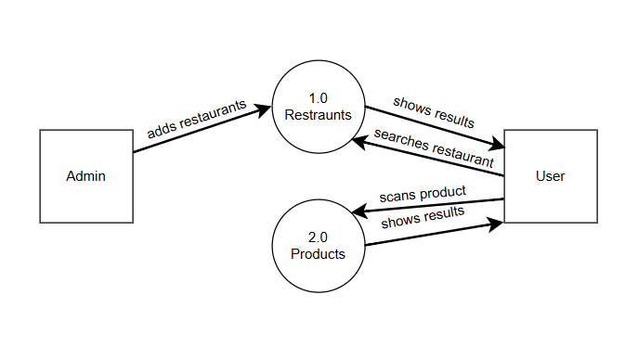

Domain Model Diagram:
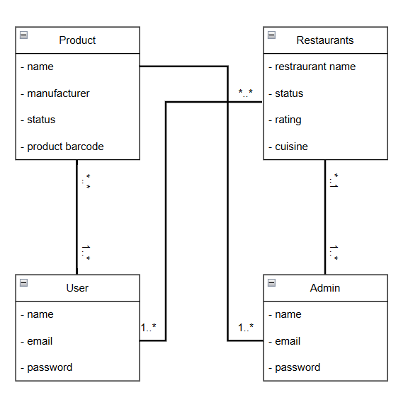

System Sequence Diagrams:
- Login SSD
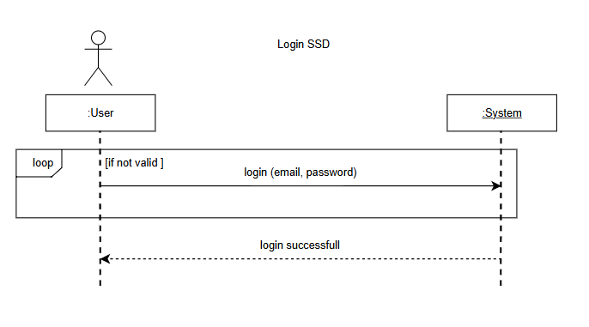
- Registration SSD
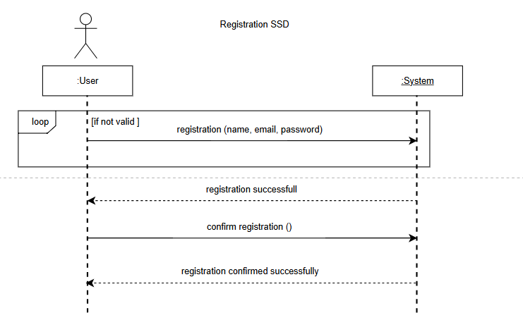
- Scan Product SSD
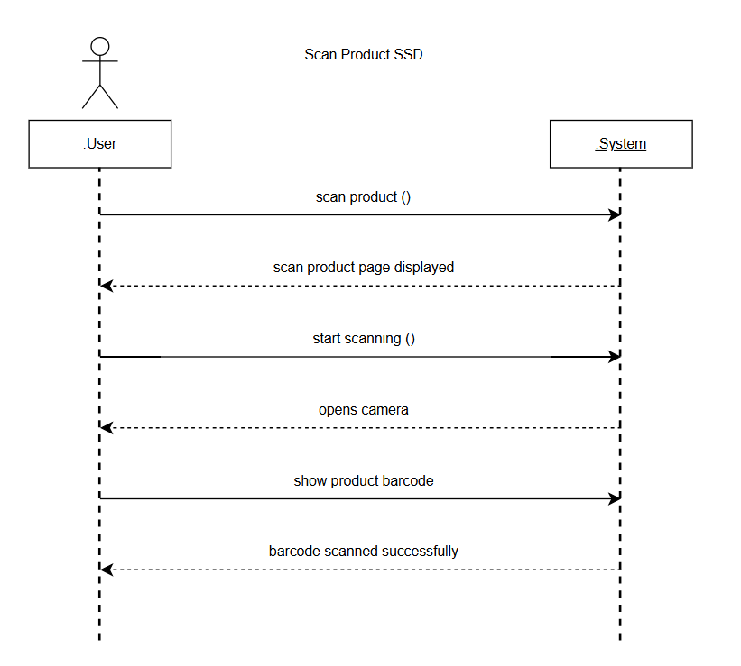
- Alternative Suggestion SSD
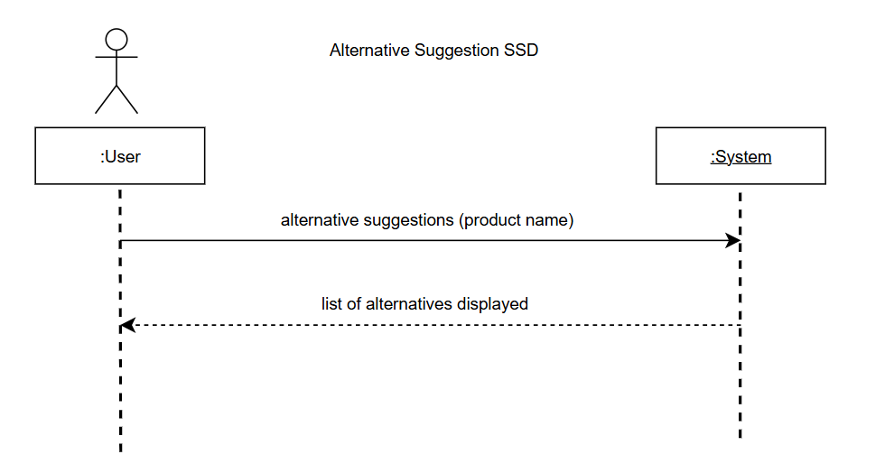

- Search Restaurant SSD
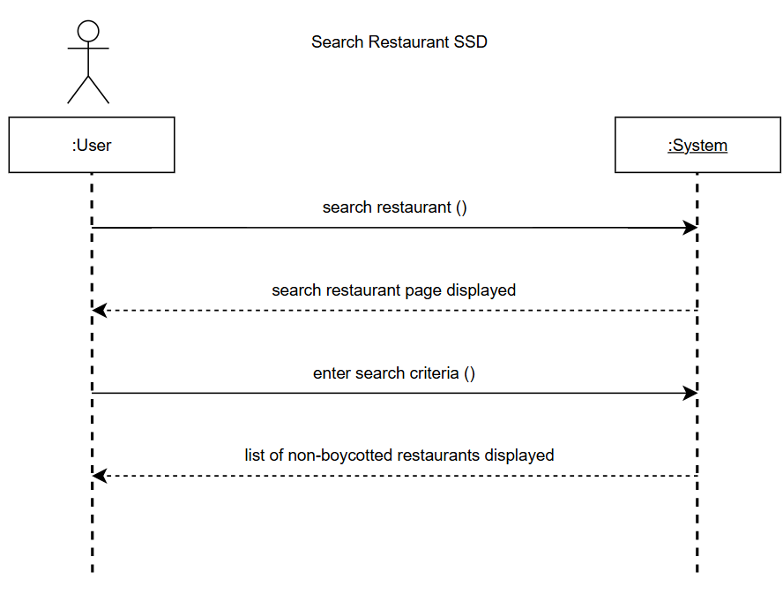
- Switch Language SSD
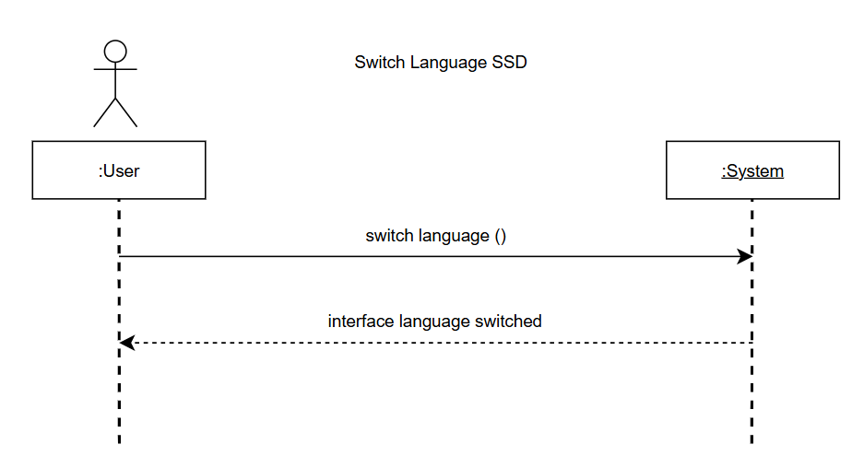

Share Scanned Product SSD
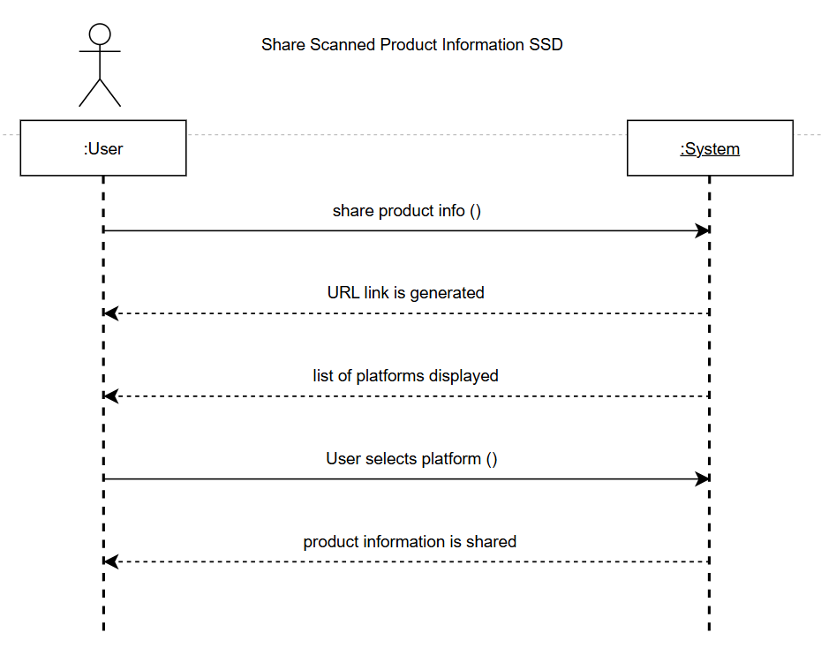

Test Cases
- Test Case 1
Test Code | TC-001
Test Case Name: | Registration
Created By | Fasih Farhaj |  | Dated: |  | 15-06-2025
Executed By | Fasih Farhaj |  | Version |  | 1.0
System | Buy Right Web Application
Objectives | Verify user can successfully register with valid credentials.
Test Type | Black Box Testing
Preconditions | Registration page is accessible and user is not already registered.
Test Case ID | Test Steps | Expected  Result |  | Actual  Result |  | Status
TC-1 | - Navigate to the registration page  - Enter a valid name, email and password.  - Click the registration button. | - System displays a success message  - User is redirected to the login page |  | - System displays a success message  - User is redirected to the login page |  | Pass
TC-2 | - Enter invalid email.  - Click the registration button. | - System displays an error message for invalid email.  - User remains on the registration page. |  | - System displays an error message for invalid email.  - User remains on the registration page. |  | Pass
- Test Case 2
Test Code | TC-002
Test Case Name: | Login
Created By | Azka Maryam |  | Dated: |  | 15-06-2025
Executed By | Azka Maryam |  | Version |  | 1.0
System | Buy Right Web Application
Objectives | Verify user/admin can successfully login with valid credentials.
Test Type | Black Box Testing
Preconditions | User/Admin is already registered and login page is accessible.
Test Case ID | Test Steps | Expected  Result |  | Actual  Result |  | Status
TC-1 | - Navigate to the login page by pressing the login button.  - Enter a valid email and password.  - Click the login button. | - System validates credentials and user/admin is logged in.  - User/Admin is redirected to the home page. |  | - System validates credentials and user is logged in.  - User/Admin is redirected to the home page. |  | Pass
TC-2 | - Enter an incorrect password.  - Click the login button. | - System displays an “Incorrect username or password” message.  - User/Admin remains on the login page. |  | - System displays an “Incorrect username or password” message.  - User/Admin remains on the login page |  | Pass

- Test Case 3
Test Code | TC-003
Test Case Name: | Scan Barcode
Created By | Ibtesam ul Haque |  | Dated: |  | 15-06-2025
Executed By | Ibtesam ul Haque |  | Version |  | 1.0
System | Buy Right Web Application
Objectives | Verify user can scan a barcode and retrieve product information.
Test Type | Black Box Testing
Preconditions | The user is logged into the system and has internet and camera access permission.
Test Case ID | Test Steps | Expected  Result |  | Actual  Result |  | Status
TC-1 | - Navigate to the scan feature.  - Align the camera with a valid barcode.  - Click the scan barcode button. | - The system retrieves and displays product information |  | - The system retrieves and displays product information. |  | Pass
TC-02 | - Scan an unreadable barcode.  - Click the scan button. | - System tells the user to try again.  - No product information is displayed. |  | - No product information is displayed and system tells the user to try again. |  | Pass

- Test Case 4
Test Code | TC-004
Test Case Name: | Display boycotted Product Suggestions
Created By | Fasih Farhaj |  | Dated: |  | 15-06-2025
Executed By | Fasih Farhaj |  | Version |  | 1.0
System | Buy Right Web Application
Objectives | Verify system displays alternative product suggestions for boycotted products
Test Type | Black Box Testing
Preconditions | User has successfully scanned barcode of the product.
Test Case ID | Test Steps | Expected  Result |  | Actual  Result |  | Status
TC-1 | - Scan a barcode marked as boycotted. | - System checks if the product is boycotted.  - The system then displays a list of alternative suggestions. |  | - System checks if the product is boycotted.  - System displays a list of alternative suggestions. |  | Pass
TC-2 | - Scan a product with no alternative available. | - System displays message to user that no alternatives are available. |  | - System displays message to the user that no alternatives are available. |  | Pass

- Test Case 5
Test Code | TC-005
Test Case Name: | Search for Non-Boycotted Products
Created By | Azka Maryam |  | Dated: |  | 15-06-2025
Executed By | Azka Maryam |  | Version |  | 1.0
System | Buy Right Web Application
Objectives | Verify that user can search for restaurants that are not marked as boycotted.
Test Type | Black Box Testing
Preconditions | User is logged in and has internet access.
Test Case ID | Test Steps | Expected  Result |  | Actual  Result |  | Status
TC-1 | - Navigate to restaurant search feature.  - Click “Search Restaurants” and enter a valid criteria.  - Click submit. | - System displays the list of non-boycotted restaurants based on user criteria. |  | - System displays the list of non-boycotted restaurants based on user criteria. |  | Pass
TC-2 | - Enter invalid search criteria.  - Click submit. | - System displays the message that no restaurants match the criteria.  - No results are displayed. |  | - System displays the message that no restaurants match the criteria.  - No results are displayed. |  | Pass

- Test Case 6
Test Code | TC-006
Test Case Name: | Switch Interface Language
Created By | Ibtesam ul Haque |  | Dated: |  | 15-06-2025
Executed By | Ibtesam ul Haque |  | Version |  | 1.0
System | Buy Right Web Application
Objectives | Verify user can switch interface language between English and Urdu.
Test Type | Black Box Testing
Preconditions | User is logged in and interface supports both languages i.e. English and Urdu.
Test Case ID | Test Steps | Expected  Result |  | Actual  Result |  | Status
TC-1 | - Navigate to the language settings.  - Select any language between English and Urdu.  - Save the selection. | - System changes interface to the selected language. |  | - System changes interface to the selected language. |  | Pass

- Test Case 7
Test Code | TC-007
Test Case Name: | Share scanned product information
Created By | Fasih Farhaj |  | Dated: |  | 15-06-2025
Executed By | Ibtesam ul Haque |  | Version |  | 1.0
System | Buy Right Web Application
Objectives | Verify user can share product information and alternative suggestions.
Test Type | Black Box Testing
Preconditions | User has scanned the product and information is displayed to the user.
Test Case ID | Test Steps | Expected  Result |  | Actual  Result |  | Status
TC-1 | - Scan a product barcode.  - Click the share button and select a platform.  - Confirm sharing. | - System retrieves product info and alternatives.  - System shares the snapshot of the result via the chosen platform. |  | - System retrieves product info and alternatives.  - System shares the snapshot of the result via the chosen platform. |  | Pass
TC-2 | - Share snapshot without internet connection.  - Click the share button. | - System displays “No internet connection” message.  - The snapshot is not shared. |  | - System displays “No internet connection” message.  - The snapshot is not shared. |  | Pass

Appendix B:

- Index page
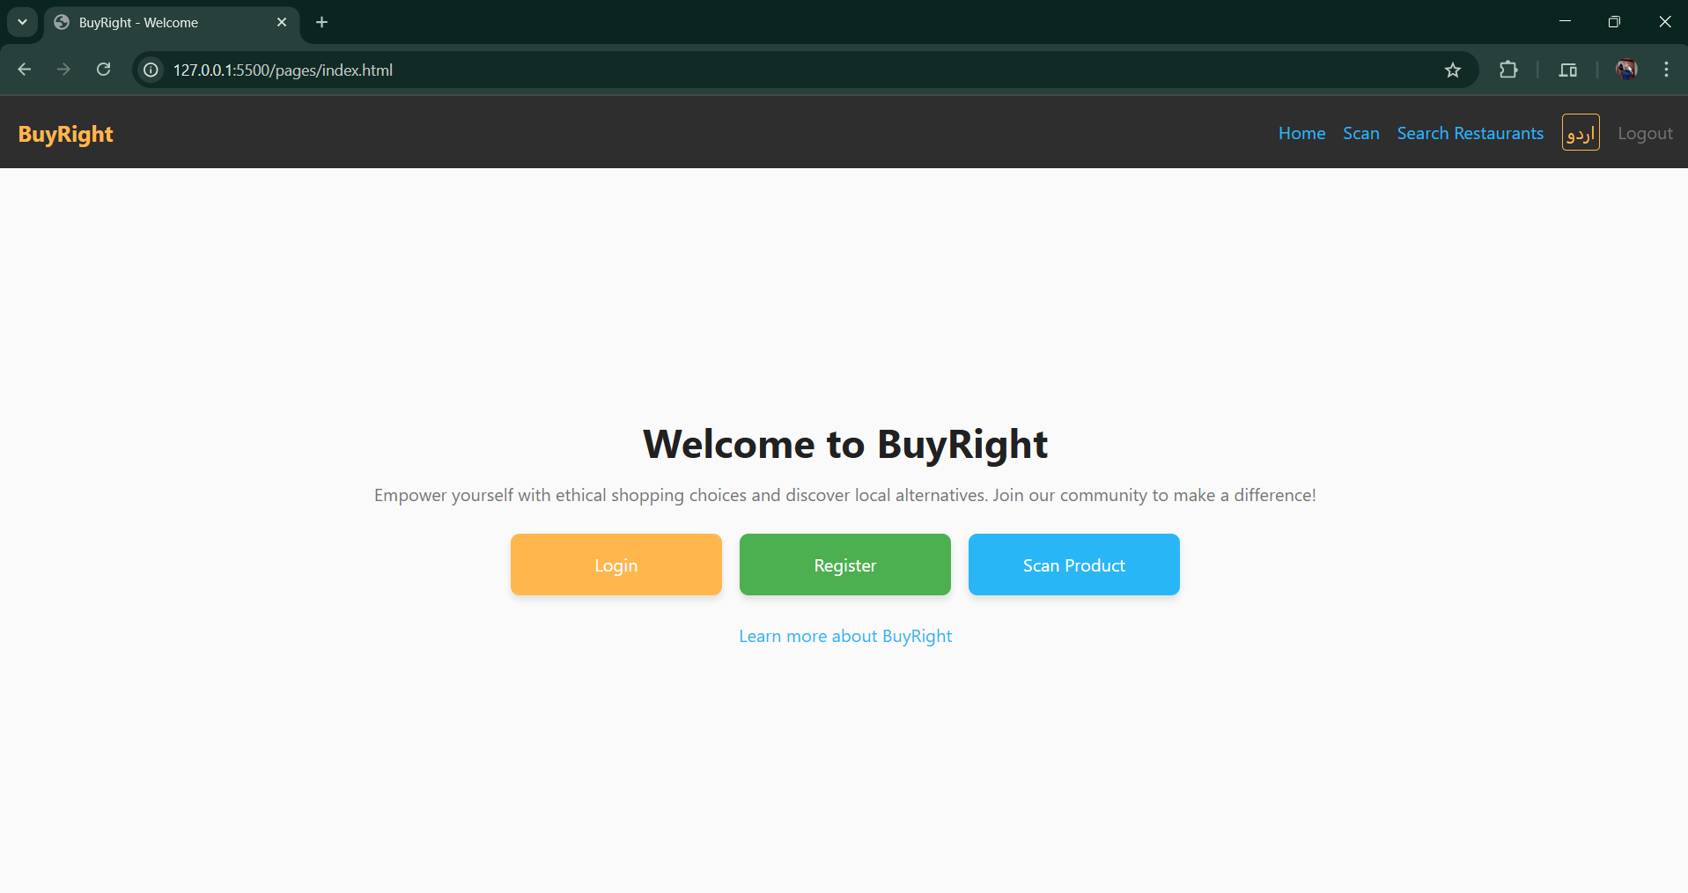
- Home page
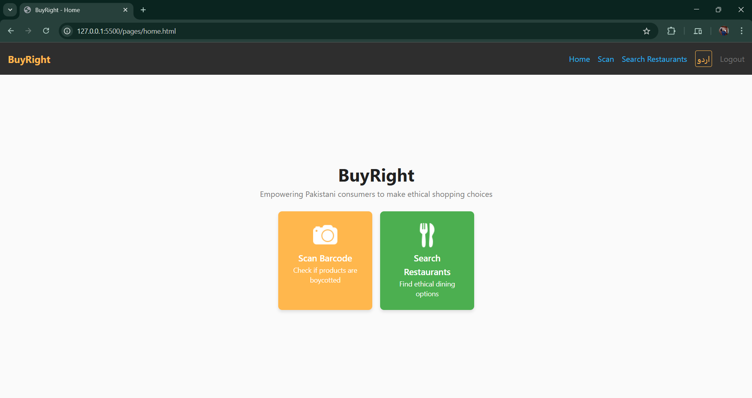

- Login page
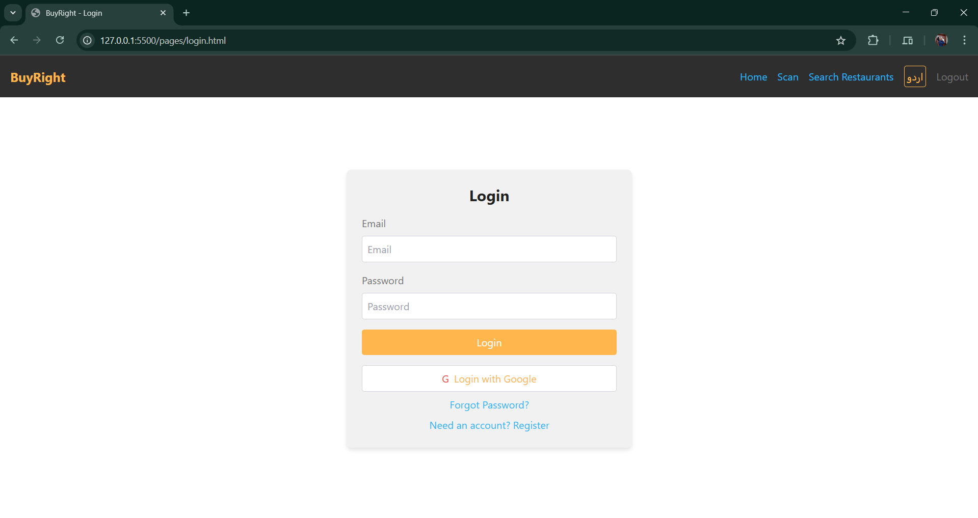

- Register page
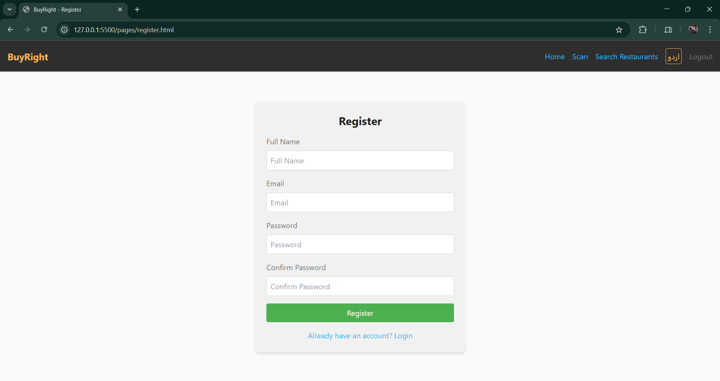

- Scan Product page
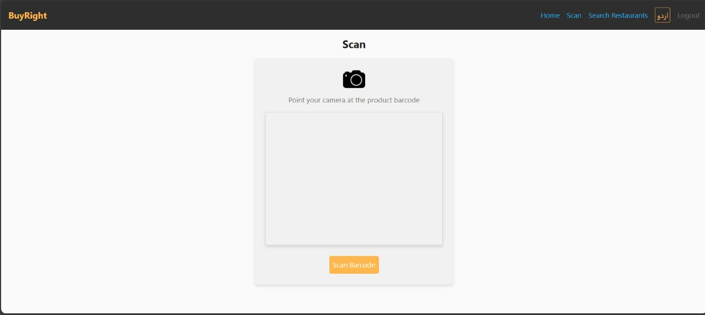
- Scan Result page
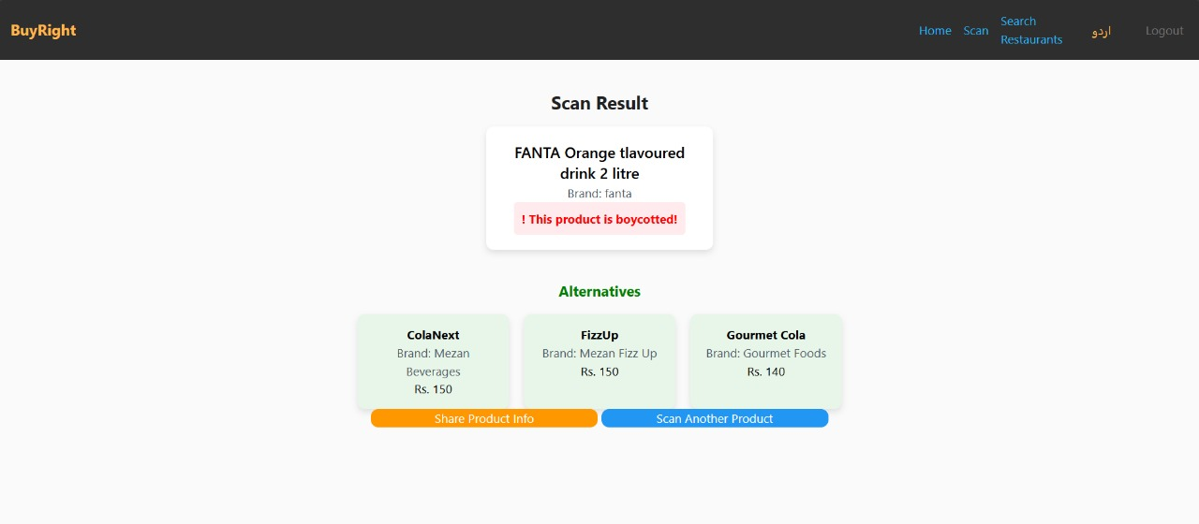

- Restaurants List page
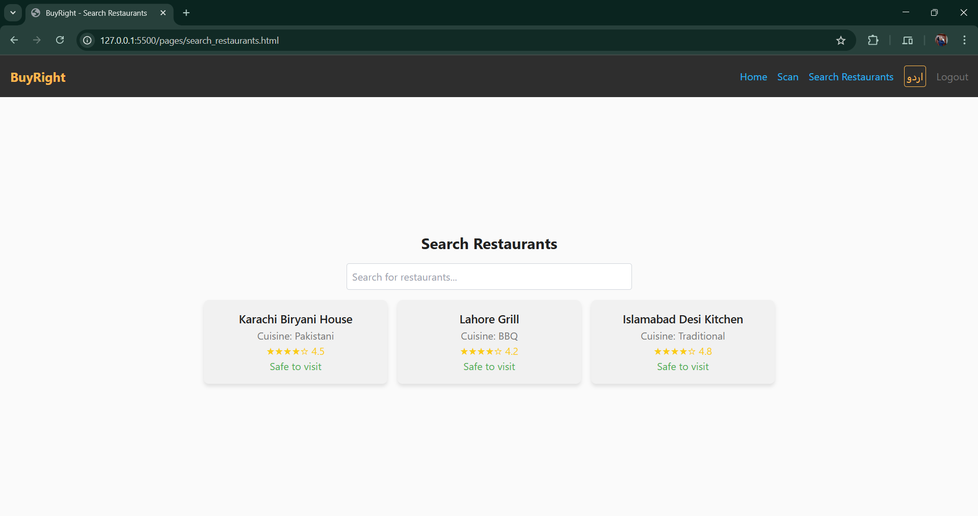
- About page
